Date : 29th Jun 2022

Author : Kasshyap Paritala

Advance Excel Assignment 4

1. To use the ribbon commands, what menu and grouping of commands will you find the Insert and Delete command? – [HOME]

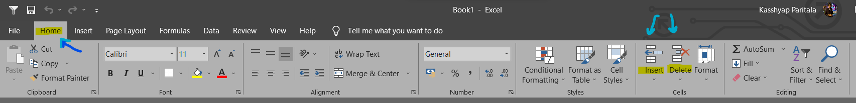

1. If you set a row height or column width to 0 (zero), what happens to the row and column?
   * It would **hide** the Row/Column.
2. Is there a need to change the height and width in a cell? Why?
   * It depends on the amount of data present inside the respective cell so that the overall information looks presentable in a quick glance.
3. What is the keyboard shortcut to unhide rows?
   * **Ctrl+Shift+(** to Unhide Rows
4. How to hide rows containing blank cells?
   * + Self-Made GIF
       - Ctrl+G (for Go To option Box)
       - Ctrl+9 (to hide Rows)



1. What are the steps to hide the duplicate values using conditional formatting in excel?

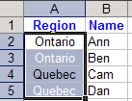

Follow these steps to hide the duplicates, and you can see the steps in the video above.

1. Select range A2:A5
2. On the Ribbon's Home tab, click the Conditional Formatting button, then click New Rule
3. Click *Use a Formula to Determine Which Cells to Format*
   * NOTE: In Excel 2003, choose Format|Conditional Formatting
   * Then, from the first drop-down, choose *Formula Is*
4. For the formula, enter  
   **=A2=A1**
5. Click the Format button.
6. Select a font colour to match the cell colour.
7. Click OK, click OK

